AFRO BLUE (Concert Fm) (Gm for trumpet/clarinet, Dm for saxophone)
Josh plays first 2 bars of 1st line, then rest of band comes in
Josh plays first 2 bars of 2nd line, then rest of band comes in
8 bars of band vamping over concert Fm
Everyone plays through whole page (sections A,B,C,B,) Note this includes 8 bars of vamping.
2 solos: Paul, then Josh. Musicians are responsible for cuing next player.
Everyone plays part C and B
More solos: Max and maybe Mike (guitar)
Everyone plays through whole page (sections A,B,C,B,) Note this includes 8 bars of vamping.
End on slow repeat of last line of part “B”

TAKE FIVE (Concert Ebm) (Fm for trumpet/clarinet, Cm for saxophone)
Structure of song is “A-B-A”
Start with 8 bars of piano and drums (maybe guitar and base comes in after 4 bars)
Everyone plays through A-B-A
Solos over chords in part “A.” Musicians are responsible for cuing next player.
Everyone plays through A-B-A
Ending based on last line of section “A”

CANTALOUPE ISLAND (Concert Fm) (Gm for trumpet/clarinet, Dm for saxophone)
Intro (8 bars), lead-in notes to melody on 8th bar
Everyone plays melody through twice (2 x 16 bars)
Solos (musicians responsible for cuing each other. Try and keep it to multiples of 16 bars
Soloists “trade 4’s” (need four soloists for this so it works out to 16 bars)
Everyone plays first 8 bars of melody together, then repeat bars 9 three times, then END.

Paul McCann (Mom Beth) 617-497-8487 (no cell) elizabeth.mccann@state.ma.us
Max Kaufman (mom Kim) 617-905-4104
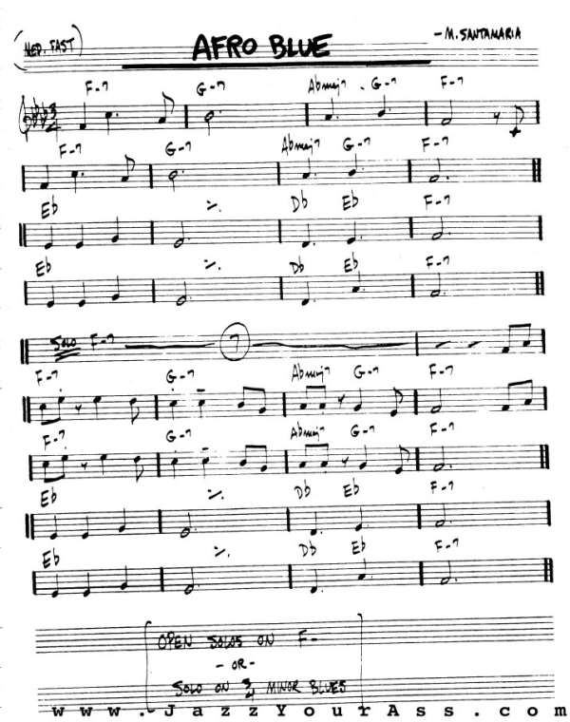
C
A
A
B

